1. ### part (a)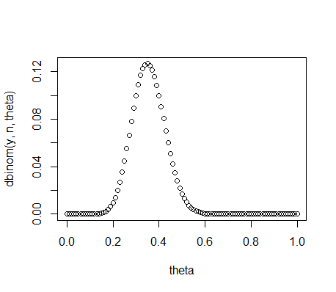

n = 43

y = 15

theta = seq(0, 1, by = 0.01)

priorvalues = dbeta(theta, 2, 8)

plot(theta, dbinom(y, n, theta))

lik <- function(theta){

choose(n,y)*theta^(y)*(1-theta)^(n-y)

}

plot(theta, lik(theta), type = "l")

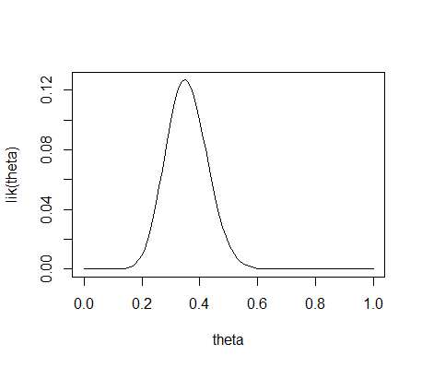

bayes <- function(theta){

(lik(theta)*theta)/y

}

plot(theta, bayes(theta))

mean(theta)

# Create the function.

getmode <- function(theta) {

uniqv <- unique(theta)

uniqv[which.max(tabulate(match(theta, uniqv)))]

}

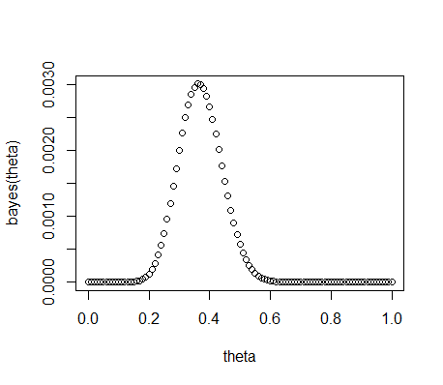

# Calculate the mode using the user function.

result <- getmode(theta)

print(result)

sd(theta)

beta_interval(0.95, c(2,8))

mean = 0.5  
mode = 0  
standard deviation = 0.2930017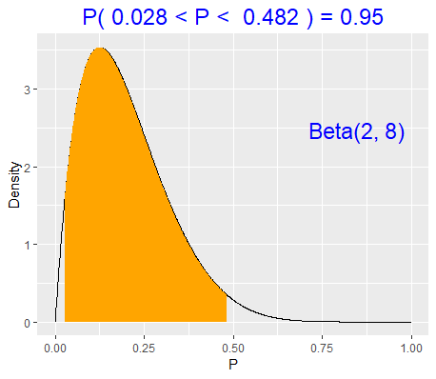

2.  
 ### part (a)

n = 43

y = 15

theta = seq(0, 1, by = 0.01)

priorvalues = dbeta(theta, 8,2)

plot(theta, dbinom(y, n, theta))

lik <- function(theta){

choose(n,y)*theta^(y)*(1-theta)^(n-y)

}

plot(theta, lik(theta), type = "l")

bayes <- function(theta){

(lik(theta)*theta)/y

}

plot(theta, bayes(theta))

mean(theta)

# Create the function.

getmode <- function(theta) {

uniqv <- unique(theta)

uniqv[which.max(tabulate(match(theta, uniqv)))]

}

# Calculate the mode using the user function.

result <- getmode(theta)

print(result)

sd(theta)

beta_interval(0.95, c(8,2))

mean = 0.5

mode = 0

standard deviation = 0.2930017  
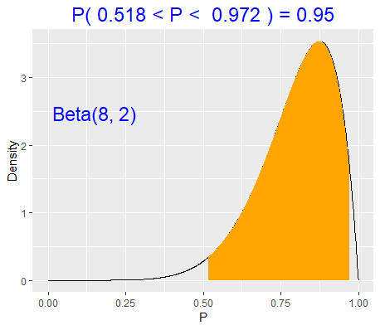

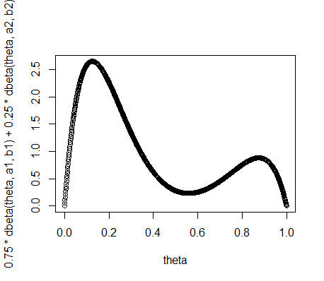

3. This prior indicates that we are fairly sure that the majority of teens do not commit another offense, but if they do then the majority of teens do. There is no in-between. It is either extreme but more likely the lower extreme than the higher one.